ADVENTURES IN PRACTICE
Adapted from Vahl Piano Studio document

How To Begin A New Piece
1. SILENT STUDY

◻ To learn a new piece you need to understand it—answer these questions first:
◻ What does the piece’s title tell me?
◻ What is the time signature, key signature, tempo, character?
◻ What are the musical markings? Use a music dictionary.
◻ What is the form? AB? ABA? Introduction? Coda? Repeats? DC al Fine?
◻ Are there patterns? Scale passages? Chords? Jumps? Repeated notes?
◻ Where is the melody? What kind of accompaniment is used?
◻ What is the starting hand position? Does it stay in one position or move?
◻ Who is the composer?
◻ What is the musical period?

2. SIGHT READ
◻ Set a VERY slow, steady tempo.
◻ Sight-read piece from beginning to end.
◻ Play without stopping, repeating, or pausing.
◻ Keep going no matter what happens.

3. MARK THE TROUBLE SPOTS

◻ Pencil mark each trouble spot so you know where to drill
◻ These will be the areas you drill at least 5 times each day until mastered.
◻ Decide what makes this a trouble spot so you know how to practice it.
◻ Is it tricky rhythm? Fingering? Tricky notes? Jumps?
2
1
4. NUMBER THE PRACTICE SECTIONS
4
◻ Number the beginning of each practice section.
3
◻ Use a pencil—mark your music.
◻ Practice sections should be short—4-8 measures only.
◻ Practice sections will later become memory sections.

HOW TO PRACTICE EVERYDAY!

- PREPARE TO PRACTICE
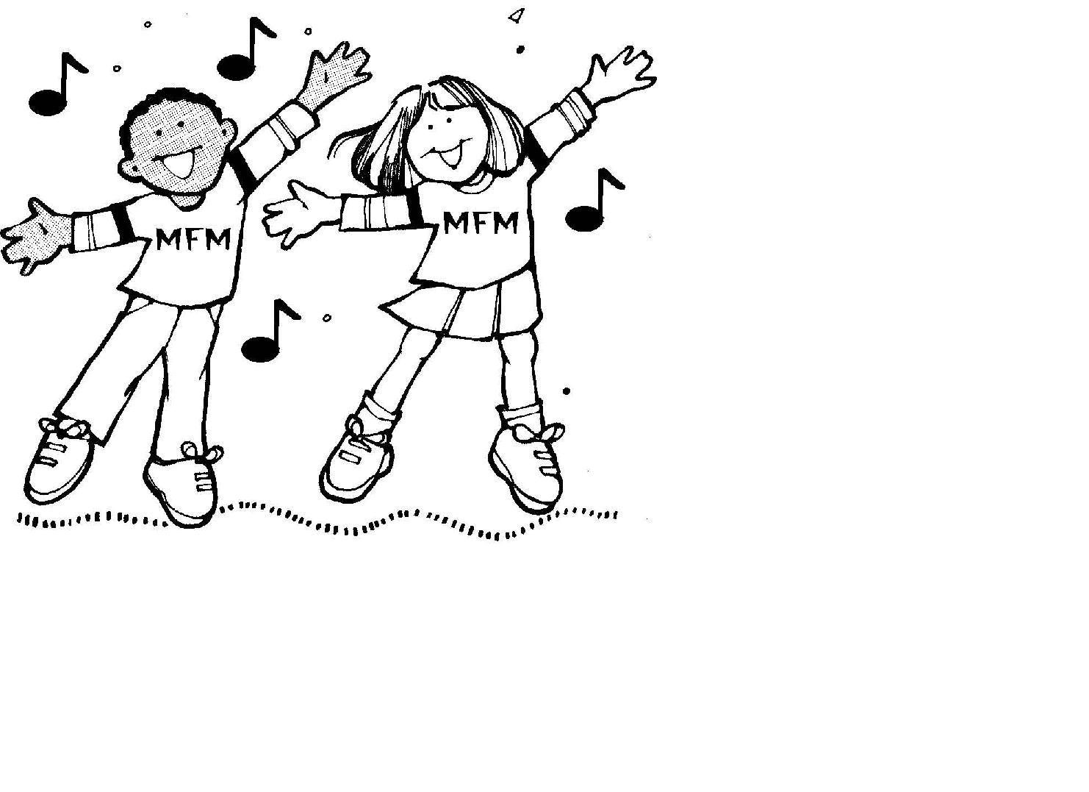
- Come to the piano with a GREAT attitude.
- Be Positive!
- Come to the piano ready to work hard!
- Get rid of distractions!
- Concentrate! Practicing is
90% mental exercise, 10% physical.

- SET DAILY PRACTICE GOALS

• Ask yourself—”What am I going to accomplish today?
• Set specific goals that can be done in one practice session.
• Think small—Concentrate on only one or two problems each day.

- RELAX!

• Prepare Hand Position
• Prepare Body Posture
- WARM-UP!
• Practice 5 finger warm ups, scales (one or two octaves),
arpeggios, chord progressions, whatever your teacher has assigned in your lesson.

- DISCOVER THE MUSICAL ADVENTURES

NOW YOU CAN PLAY...

#1

First Adventure: NOTES, RHYTHM, FINGERING Goals:
Goals:

- To play piece beginning to end without stopping, pausing, or repeating.
- To play confidently with correct notes, fingering, and rhythm.
- To play and count aloud.
- To play at a slow controlled tempo.

STEP ONE: Complete HOW TO BEGIN A NEW PIECE

STEP TWO: Practice what you don`t know... Not what you do know

- Practice trouble spots only . . . Do not start at the beginning of the piece.
- Practice slowly and carefully! Learn everything correctly the first time!
- Trouble spots will be small areas – several notes or one phrase only.
- Practice smart. Drill trouble spots to solve the problem.

♫ For All Trouble Spots—Practice HS, then HT when HS is mastered.
♫ For Tricky Fingering—Pencil in a comfortable fingering. Use the same
fingering all the time.
♫ For Tricky Rhythm—Clap, tap, count aloud for tricky rhythms.
♫ For Difficult Passages—Practice in rhythms, block the chords, change
dynamics, change articulation, regroup phrases, accent different notes,
practice slowly with the metronome.
♫ For Position Changes—Practice the moves and hand shapes silently,
practice without looking, memorize how it feels.

STEP THREE: Build Musical Bridges
- Extend practice to include notes before and after each trouble spot.
- Build bridge to trouble spot by adding one or more measures before.
- Build bridge from trouble spot by adding one or more measures after.
- Build larger bridges by drilling the entire practice section.
- Continue practicing section by section, connecting sections for entire piece.

STEP FOUR: Play the piece from beginning to end.

- Listen for improvements and trouble spots.
- Set goals for tomorrow’s practice.

Second Adventure: DYNAMICS, ARTICULATION, PEDALLING
#2

Goals:

- To play piece musically, with all dynamic markings
and articulation.
- To play piece slowly and confidently.
- To play piece with a good tone.
- Understand all markings . . . Dynamics, tempo markings, phrases, slurs,
staccatos, accents, fermatas.
- Understand what the music says—Listen as you play so you hear it.
- Shape phrases, ending gracefully.
- Listen for balance between melody and accompaniment.
- For pedaling, practice LH and pedal. Heel on the floor.

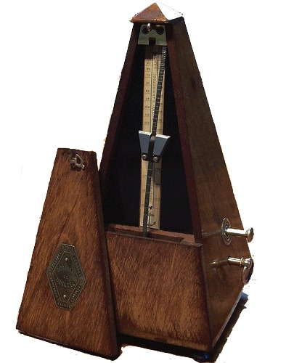
#3

Third Adventure: INTERPRETATION & TEMPO

Goals:

- To perform piece up to tempo and with confidence and
control.
- To express the mood/character of the piece.
- To perform piece stylistically correct.
- To increase tempo, gradually add speed day by day.
- Use metronome to build tempo, increasing one notch at a time.
- Play to convey the mood and style of the piece. Is this piece
- Baroque, Classical, Romantic, Contemporary? Ragtime? Jazz? Popular?
- Sacred?
- Create a visual picture or story to go with the music.
- Add your own flair and spirit.

#4
Fourth Adventure: MEMORIZATION

#5
Fifth Adventure: PERFORMANCE

